

CSA0501-DATABASE MANAGEMENT SYSTEMS

LAB EXPERIMENTS DATE: 29/07/2026

EXPERIMENT 20–MYSQL STRING FUNCTIONS- REPLACE, REPEAT,REVERSE, RIGHT, LEFT, RPAD,LPAD
AIM:
To implement the MySQL string functions REPLACE(), REPEAT(), REVERSE(), RIGHT(), LEFT(), RPAD(), and LPAD() using the milka_dairy table.
procedure

- Create the milka_dairy table and insert the required records.
- Use the SELECT statement to retrieve data from the milka_dairy table.
- Use the REPLACE() function to replace the bank name SBI with STATE BANK.
- Use the REPEAT() function to repeat the customer name two times.
- Use the REVERSE() function to reverse the customer name.
- Use the RIGHT() function to extract the last three characters of the customer name.
- Use the LEFT() function to extract the first three characters of the customer name.
- Use the RPAD() function to add * characters to the right side of the customer name.
- Use the LPAD() function to add * characters to the left side of the customer name.
- Use the ASCII() function to find the ASCII value of the first character of the customer name.
- Use the BIN() function to convert the amount into binary format.
- Use the OCT() function to convert the amount into octal format.

1)REPLACE()

SELECT name, REPLACE(bank_name, 'SBI', 'STATE BANK') AS replaced_bank

FROM milka_dairy;

Output:
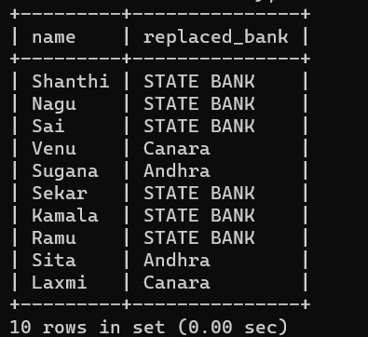

2)REPEAT()
SELECT name, REPEAT(name, 2) AS repeated_name
FROM milka_dairy;
Output
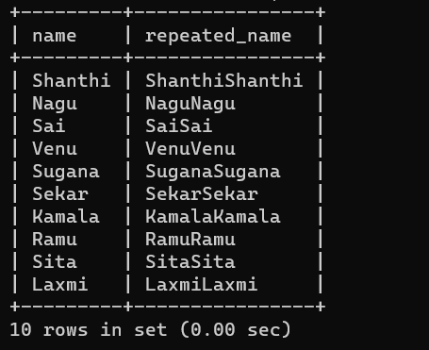

3)REVERSE()
SELECT name, REVERSE(name) AS reversed_name
FROM milka_dairy;

Output

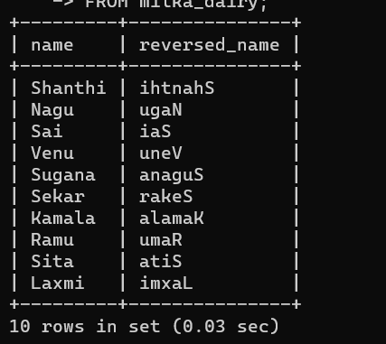

4)RIGHT()
SELECT name, RIGHT(name, 3) AS right_characters
FROM milka_dairy;
Output
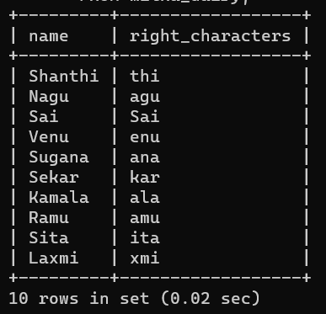

5)LEFT()
SELECT name, LEFT(name, 3) AS left_characters
FROM milka_dairy;

Output
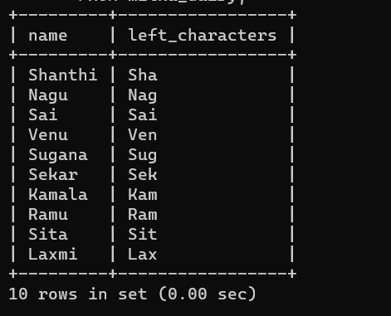

6)RPAD()
SELECT name, RPAD(name, 10, '*') AS rpad_name
FROM milka_dairy;
Output
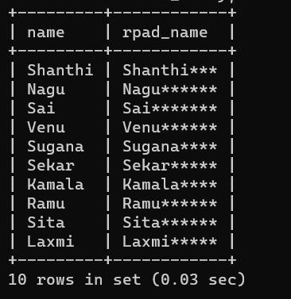

7)LPAD()
SELECT name, LPAD(name, 10, '*') AS lpad_name
FROM milka_dairy;
Output

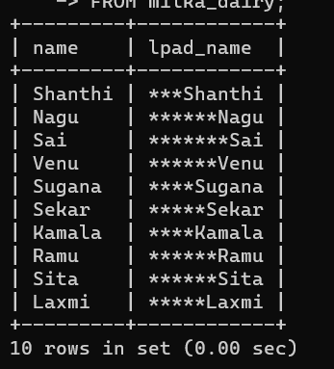

8)ASCII()
SELECT name, ASCII(name) AS ascii_value
FROM milka_dairy;
Output

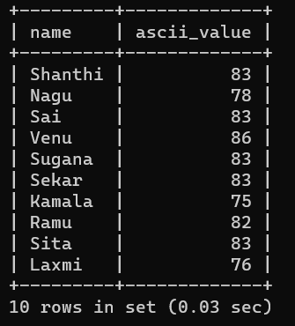

9)BIN()
SELECT name, amount, BIN(amount) AS binary_amount
FROM milka_dairy;
Output

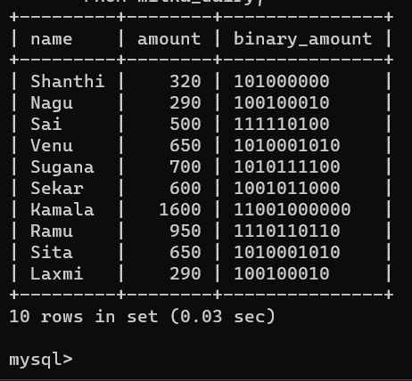

10)OCT()
SELECT name, amount, OCT(amount) AS octal_amount
FROM milka_dairy;

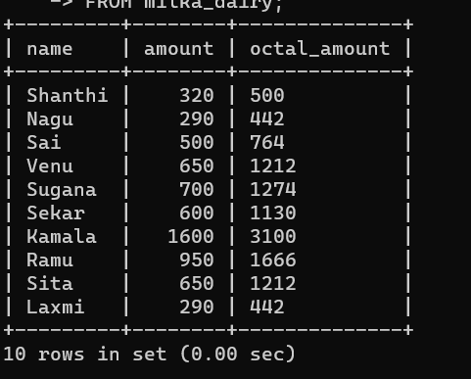

RESULT:
Thus, the MySQL string functions REPLACE(), REPEAT(), REVERSE(), RIGHT(), LEFT(), RPAD(), LPAD(), ASCII(), BIN(), and OCT() were implemented successfully using the milka_dairy table.

